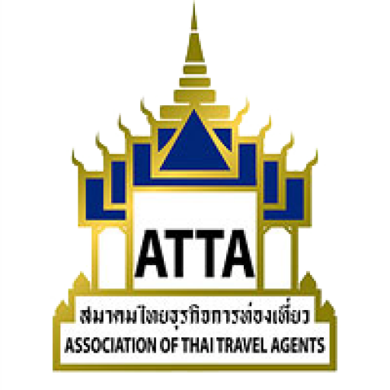

Ref.: 177 / 2561
8 August 2018
Subject: Participation in the road show in China

Dear Members,

In accordance with the Royal Thai Government’s policy for the promotion of quality and safe tourism, as well as to encourage confidence for Chinese tourists to travel to Thailand, the Association of Thai Travel Agents (ATTA) will organise a road show to China in Tianjin, Qingdao, Hefei, and Nanjing during 16-21 September, 2018. The selected cities have a total population of 250 million in which there is the opportune potential to promote and expand the market for Thai tour operators to meet with local tour operators and present quality tourism products.

On this occasion, ATTA would like to invite interested members to participate in this road show. Kindly send the attached Acceptance Form and fee in full together with a copy of the passport by fax (0-2237-6045) to the contact person: Khun Kullasatree ( Cherry ) Tel.: 02-237-6046-8 Ext. 11. ATTA will only accept 80 companies who have made a reservation and paid the fee in full by 31 August, 2018. This will be on a first come first served basis.

This is for members’ information and consideration.

Sincerely,


(Mr. Vichit Prakobkoson)
President

Encl.: 1. Itinerary
2. Acceptance Form

Road Show to China
16 – 21 September 2018
Day 1: (Sunday, 16 September, 2018) Bangkok – Tianjin.
09.00 Hrs. Meet at Check-in 6 & 7, Terminal 1, Don Mueang International Airport.
11.20 Hrs. Depart for Tianjin by Nok Scoot (flight No. XW880).
17.00 Hrs. Arrive at Tianjin Binhai International Airport (TSN)
18.00 Hrs. Check-in at The Ritz-Carlton Tianjin Hotel

Day 2: (Monday,17 September,2018)(B/L)Thailand Quality Tourism Road Show,Tianjin at The Ritz-Carlton Tianjin Hotel
Morning Breakfast at the hotel.
9.00 – 13.30 Hrs. Registration Buyers, Sellers, Media and Business networking.
12.00 Hrs. Lunch.
17.33-21.53 Hrs. Depart for Qingdao by high-speed train (G197)
Check-in at Le Meridien Qingdao Hotel

Day 3: (Tuesday, 18 September, 2018) (B/-/D) Thailand Quality Tourism Road Show, Qingdao at Le Meridien Qingdao Hotel
Morning Breakfast at the hotel and at leisure.
14.00 – 17.30 Hrs. Registration Buyers, Sellers, Media and Business networking.
18.00 Hrs. Dinner.

Day 4: (Wednesday, 19 September, 2018) (B/-/-)
06.25 - 07.55 Hrs. Depart for Hefei by Shandong Airlines (flight No, SC8761).
Check in to the Shangri-La Hotel Hefei.
Afternoon At leisure.

Day 5: (Thursday, 20 September, 2018) (B/L/-) Thailand Quality Tourism Road Show, Hefei (Shangri-La Hotel HEFEI ).
9.00 – 13.30 Hrs. Registration Buyers, Sellers, Media and Business networking.
12.00 Hrs. Lunch.
Afternoon Depart by coach for Nanjing (2.5-3 Hrs).

Day 6: (Friday, 21 September, 2018) (B/L/-) Thailand Quality Tourism Road Show, Nanjing ( Shangri-La Hotel NANJING ).
9.00 – 13.30 Hrs. Registration Buyers, Sellers, Media and Business networking.
12.00 Hrs. Lunch.
Evening Depart for Nanjing Lukou International Airport.
20.10 Hrs. Depart for Bangkok by Nok Scoot (flight No. XW 887)
23.20 Hrs. Arrive in Bangkok.
***************************************************************
Road Show to China
16 - 21 September 2018
Tianjin, Qingdao, Hefei, and Nanjing
*****************************************************************************************************
(Kindly complete clearly in English.)
Company Name ...................................................................................................................................................
Address ..............................................................................................................................................................
Tel .................................................... Fax........................................ E-mail.........................................................
Name of Participant กรุณาเขียนชื่อ สกุล ภาษาไทย ตัวบรรจง
ชื่อ – นามสกุล (นาย/นาง/นางสาว)................................................................................................................................
Please fill data in English
Name .................................................................. Surname .......................................................................... Position .................................................................. Mobile .............................................................................
Passport No. …………………………Expiry Date………..……………………Mobile……….……………..
Accompanying Person (if have) กรุณาเขียนชื่อ สกุล ภาษาไทย ตัวบรรจง
ชื่อ – นามสกุล (นาย/นาง/นางสาว)................................................................................................................................
Please fill data in English
Name ......................................................................... Surname ................................................................... Position ......................................................................... Mobile ......................................................................
Passport No. …………………………Expiry Date………..……………………Mobile……….……………...
Please select (Price includes 7% VAT)
Ordinary member: 60,000 Baht / person + 7% VAT = 64,200 Baht (Twin room / 1 table /does not include visa fee).
Ordinary member’s accompanying person: 65,000 Baht / person + 7% VAT = 69,550 Baht (Twin room /
does not include visa fee).
Associate member: 65,000 Baht / person + 7% VAT = 69,550 Baht (Twin room / does not include visa fee).
Associate member’s accompanying person: 70,000 Baht / person + 7% VAT = 74,900 Baht (Twin room /
does not include visa fee).
If want a single room : 15,000 Baht / person + 7% VAT = 16,050 Baht.
Chinese visa service fee ( 1,500 + 300 ) 1,800 Baht / person + 7% VAT = 1,926 Baht.
** For those persons who do not want an air ticket, deduct 10,000 Baht from the above price. **
Total....................................Baht
Signature ……………............................................
Company Seal Date …….......................................................
Remarks
- Send the acceptance form by E-mail (info@atta.or.th) or by fax (0-2237-6045) together with the payment in full and a copy of your passport. Payment can be made in cash at ATTA Head Office, or by bank transfer to the savings account of the KasikornThai Bank, Phatphong. Name of account: “สมาคมไทยธุรกิจการท่องเที่ยว”, Acct No.: 011-1-71468-1, and E-mail or fax a copy of the pay-in slip to ATTA by 31 August, 2018.

- In the case of cancellation, ATTA will not refund the fee.

- If you need a Chinese visa, please inform ATTA who will have the staff coordinate with you. ATTA needs your passport that has at least 6 months validity and at least 3 blank pages, two 2” colour photos with a white background (no more than 6 months old), copy of the house registration and Thai ID card, as well as fee of 1,800 Baht (1,500 baht for visa + 300 Baht service not including 7% VAT).

- For those persons who already have a Chinese visa, you can send a copy of the visa to ATTA for checking.

- The mentioned fee includes 7% VAT, air ticket, coach, accommodation, meals, insurance, but does not include the visa fee.

*****************************************

