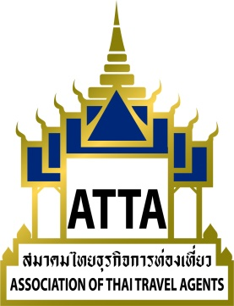

Ref.: 229/2561
17 October 2018
Subject: ATTA Monthly Meeting

To all members,

The Association of Thai Travel Agents (ATTA) will conduct the meeting for the month of October 2018 on Thursday, 25 October, 2018, in the Kamolthip Ballroom, 2nd Floor, The Sukosol Bangkok, from 10.00 hrs to 12.00 hrs (registration as from 09.00 hrs and enjoy refreshments).

For this meeting, during 11.00 - 12.00 Hrs, ATTA has arranged a special lecture on the topic “Overall Marketing Policy and Planning of TAT for 2019” by Mr. Siripakorn Cheawsamoot, Deputy Governor for Policy and Planning, Tourism Authority of Thailand (TAT). This will allow members to be updated and receive information that will benefit them in their business operations.

ATTA would like to invite all members to attend the meeting on the aforementioned date, time and venue. Following the meeting, we would like to invite you to a luncheon. As such, members (1 person/company) have the right to attend the meeting and luncheon free; accompanying persons pay 800 Baht/person. Kindly return the Acceptance Form to the ATTA Head Office by fax (02-237-6045) or e-mail (info@atta.or.th).

Sincerely,
***Sent by Email***
Mr,Vichit Prakobgosol
President

Encl.: 1. Agenda
2. Acceptance Form

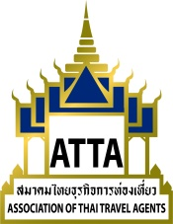

Acceptance of Attending the Monthly Meeting of October 2018
Thursday, 25 October, 2018
10.00 Hrs – 12.00 Hrs. (registration as from 09.00 Hrs.)
Kamolthip Ballroom
2nd Floor, The Sukosol Bangkok

Name- Family Name: Position: a

Company: a

Address: ฟ

Tel.: Fax: E-mail ____________________________

**************************************************************************************************************
Schedule
09.00 – 09.45 Hrs Registration and refreshments
10.00 – 12.00 Hrs Meeting
12.00 – 13.00 Hrs Luncheon
Send by fax (02-237-6045) or e-mail (info@atta.or.th).
*** Thank You***

Association of Thai Travel Agents (ATTA)
Agenda for the Monthly Meeting of October 2018
Thursday, 25 October, 2018
10.00 Hrs – 12.00 Hrs.
Kamolthip Ballroom, 2nd Floor, The Sukosol Bangkok
Agenda for the Monthly Meeting of October 2018
Registration & Refreshments | 09.00 Hrs.
Meeting | 10.00 – 12.00 Hrs
Agenda
Item 1 | 1.1 Opening of the meeting by the Chairman  - Report of the tourist statistics as at 20 October, 2018.  - Summary of the important activities for the past month.
Item 2 | Acceptance of the minutes of the meeting  Report of the meeting for the month of September 2018 on Thursday, 27 September, 2018, at the Kasatsuk Room 2, 4th Floor, Twin Towers Hotel, Bangkok (9 pages).
Item 3 | Report of the members  3.1 Status of members.  3.2 Introduction of 10 new members.
Item 4 | Introduction of new products  4.1 Chao Phraya Cruise  4.2 The Platinum Group  4.3 Bang Krachao community
Item 5 | Special lecture on the topic “Overall Marketing Policy and Planning of TAT for 2019” by Mr. Siripakorn Cheawsamoot  Deputy Governor for Policy and Planning, Tourism Authority of Thailand (TAT)
Item 6 | Other (if have).

Advantages from attending the monthly meeting:
- Members will receive continuous up-to-date information about the situation of the Thai tourism industry.
- Meet with fellow members.
- Publicise about member’s own business.
- Other rights in participating in activities subject to the appropriateness of each project.

*************************************************************************************

