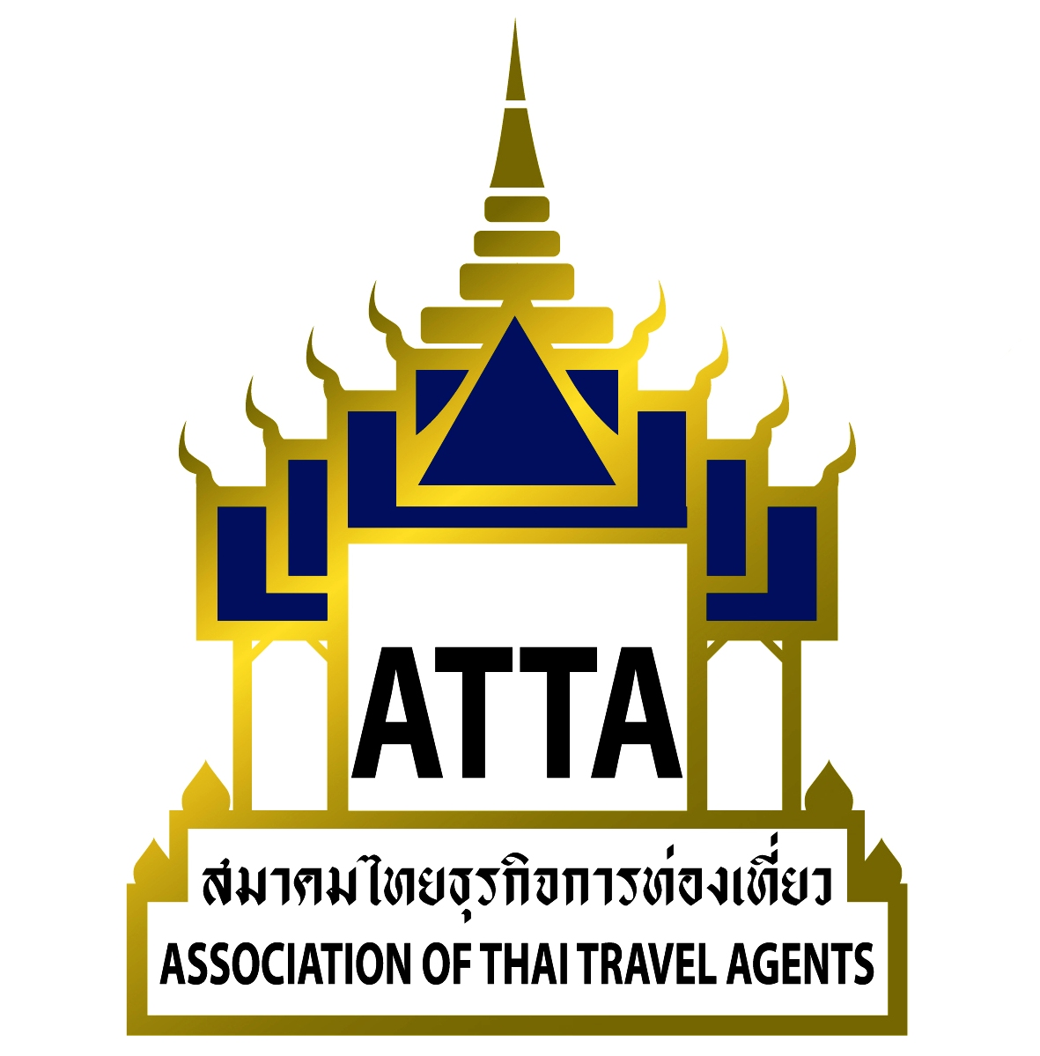

Ref.: 071/2560
8 March 2017

Subject: ATTA Annual General Meeting

To all members,

The Association of Thai Travel Agents (ATTA) will conduct the 2016 Annual General Meeting on Thursday, 30 March 2017, from 09.00 Hrs in the Napalai Ballroom, Dusit Thani Hotel, Rama IV Road, Silom, Bangkok.

The agenda is as follows:
Item 1: Opening of the meeting by the Chairman
Item 2: Acceptance of the minutes of the 2015 Annual General Meeting
Item 3: Items for consideration and achievements of the Board of Directors for 2016
Item 4: Consideration of the approval of the 2016 Balance and Loss Sheets
Item 5: Selection of the annual Auditor and cost of the auditing services
Item 6: Election of the Board of Directors for 2017-2018
Item 7: Other items

Schedule
09.00 – 10.30 Hrs Registration & refreshments
10.30 – 11.30 Hrs Meeting
11.30 – 12.00 Hrs Election of the Board of Directors and luncheon

Due to the fact that the present Board of Directors of ATTA have completed their tenure and that this Annual General Meeting will have an election of the Board of Directors for the period 2017-2018, a period of 2 years, in accordance with ATTA’s regulations, each meeting must have at least 25 percent of the total number of members in attendance. At the time of this letter, there are a total of 1,548 members; as such, there must be at least 387 members attending the above-mentioned event in order to form a quorum for the reporting of the business activities and operations of the Board of Directors as well as the balance and loss for the year 2016. Therefore, ATTA is informing all members of the forthcoming Annual General Meeting for their consideration.

Furthermore, in accordance with Article 7 Item 34 of ATTA’s regulations, each ordinary member has the right to one (1) vote. In exercising the right to vote of an ordinary member, the person exercising the right must be 1 of 3 representatives in the name list that the member has submitted to ATTA only. In addition, a member cannot authorize another person to use their voting right. Therefore, we request that all members to bring their Thai identification card with them.

This is therefore for members’ information and consideration to participate in the meeting.


Sincerely,

Mr.Charoen Wangananont
President

Encl.: 1. Acknowledgement of attendance

Remark: Each ordinary member has the right to one (1) vote to utilize in the Annual General Meeting. The person exercising the right must be 1 of 3 representatives in the name list that the member has submitted to ATTA only. In addition, a member cannot authorize another person to use their voting right.

Acceptance of Attending the 2016 Annual General Monthly Meeting
Thursday, 30 March, 2017 at 09.00 am.
Napalai Ballroom, Dusit Thani Hotel, Rama IV Road, Silom, Bangkok.
Please confirm your attendance by fax: 0-2237-6045 or e-mail : info@atta.or.th

Participant’s Name: Position:
Company:
Address :
Tel: Fax : Membership No.:

Category:  Active Member ( Market )  Allied Member

Registration Fee: 1 person per company (free)
 Invited guests 850 Baht (incl. VAT)

Signature
( )
Position

Date

**Thank you for your cooperation. **

