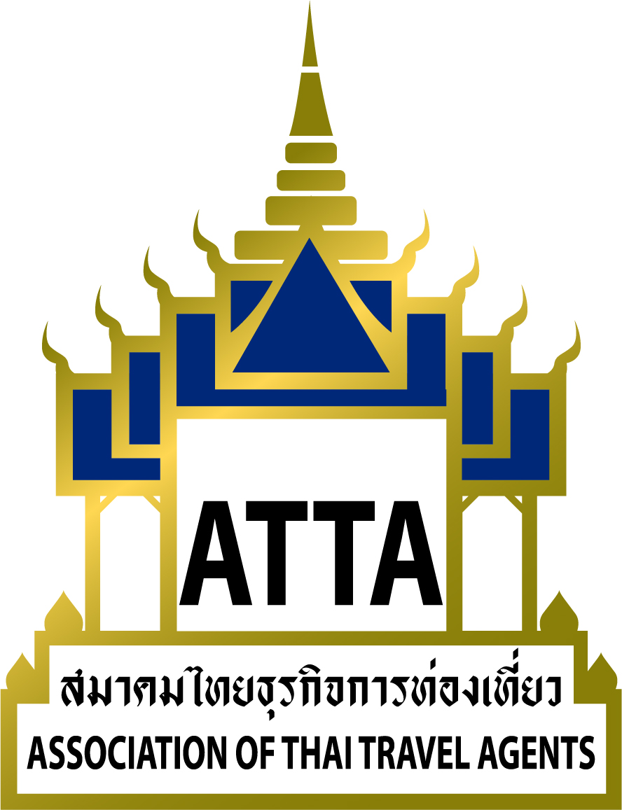

Ref.: 391 / 2559
19 December 2016
Subject: ATTA Monthly Meeting

To all members,

The Association of Thai Travel Agents (ATTA) will conduct the meeting for the month of December 2016 on Thursday, 29 December, 2016, in the Grand Ballroom, 4th Floor, Intercontinental Hotel, Bangkok, from 11.00 Hrs to 15.30 Hrs (registration as from 11.00 Hrs and lunch at 12.00 Hrs).

For this meeting, ATTA has arranged a special lecture on the topic “The Global Economic Situation for 2017 and the Effect on the Thai Tourism Industry” to be given by Asst. Prof. Dr. ThanawatPolvichai as Director of University of the Thai Chamber of Commerce’s Center for Economic and Business Forecasting (CEBF) This will allow members to be updated and exchange of information that will benefit them for their business operations.

ATTA would like to invite all members to attend the meeting on the aforementioned date, time and venue. Following the meeting, we would like to invite you to a luncheon. As such, members (1 person/company) have the right to attend the meeting and luncheon free; accompanying persons pay 800 Baht/person. This is therefore for members’ information and consideration to participate in the meeting. Kindly return the Acceptance Form to the ATTA Head Office by fax (02-237-6045) or e-mail (info@atta.or.th).

Sincerely,

Sent by Email

Mr.Charoen Wangananont
President

Acceptance of Attending the Monthly Meeting of December 2016
Thursday, 29 December, 2016
11.00 Hrs to 15.30 Hrs
(registration as from 11.00 Hrs and lunch at 12.00 Hrs)
Grand Ballroom, 4th Floor, Intercontinental Hotel, Bangkok

**************************************************************************************************************

Name- Family Name________________________________________________________

Position: Mobile __________________________ a
Company: Membership No.: __________________

Address:___________________________________________________________________

__________________________________________________________________________

Tel.: Fax: ____ .E-mail: ___________________

Registration Fee: 1 person per company (free)
Invited guests 800 Baht (incl. VAT)

**************************************************************************************************************

Schedule

11.00 – 12.00 Hrs. Registration
12.00 – 13.00 Hrs. Lunch
13.30 – 15.30 Hrs. Meeting

Association of Thai Travel Agents (ATTA)
Agenda for the Monthly Meeting of December 2016
Thursday, 29 December, 2016
11.00 Hrs – 15.30 Hrs.
Grand Ballroom, Intercontinental Hotel, Bangkok

Agenda for the Monthly Meeting of December 2016

Registration | 11.00 Hrs.
Luncheon | 12.00 Hrs.
Meeting | 13.30 – 15.30 Hrs.
Agenda
Item 1 |  | Opening of the meeting by the Chairman  Summary of the important activities for the past month.  Report of the tourism situation in Thailand and statistics of tourists as at 20 December, 2016.
Item 2 |  | Acceptance of the minutes of the meeting  Report of the meeting for the month of November 2016 on Thursday, 24 November, 2016, at the Maenam Grand Ballroom, 2nd Floor, Ramada Plaza Bangkok, Maenam Riverside Hotel, Bangkok.
Item 3 |  | Report of the members  3.1 Status of members.  3.2 Introduction of new members for December 2016
Item 4 |  | New Products
Item 5 |  | Special Lecture “The Global Economic Situation for 2017 and the Effect on the Thai Tourism Industry”  by Asst. Prof. Dr. ThanawatPolvichai as Director of University of the Thai Chamber of Commerce’s Center for Economic and Business Forecasting (CEBF)

