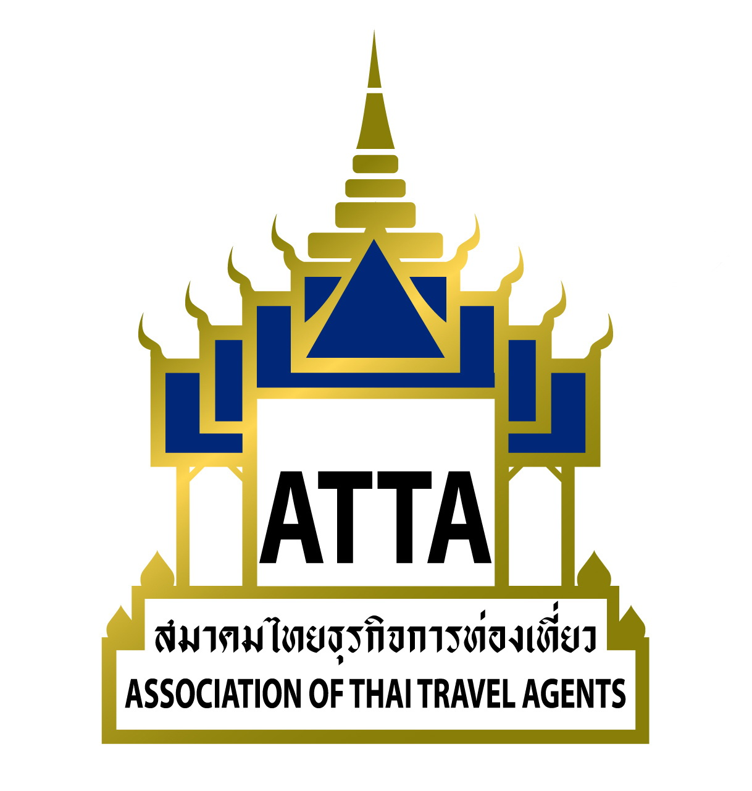

Update Form for ATTA Directory 2017-201888

- Please complete the data in this form for updating your records for the ATTA Directory 2017-2018 and return to ATTA office by 30 June 2017. If you do not reply within the deadline (30 June 2017), we will print your organization existing data in the new ATTA Directory 2017-2018.

- ATTA Contact Person: Khun Thanit Sawaengpruck (To) Tel: 0-2237-6046-8 ext.12

Khun Kochaporn Nenleab (Bung) Tel: 0-2237-6046-8 ext.16

Khun Kodchaphan Wantanunkit (Tik) Tel: 0-2237-6046-8 ext.24

Fax: 0-2237-6045 E-mail: info@atta.or.th

- Type of member ATTA Active Member ATTA Allied Member

Please print in English by typing.

- Company Name:

- Address:

- Telephone No. / Fax No.

- E-mail Address: / Website:

- Year of establishment: / ATTA Member No.

- TAT License No.

- Type of business:

Inbound Outbound Inbound & Outbound

Hotel & Resort Other

- Contact person : 1. Mr./Ms./Mrs.

Position:

2. Mr./Ms./Mrs.

Position:

3. Mr./Ms./Mrs.

Position:

For the Active Member

9) Major Market :

(Example: China , Japan , French ,… etc.)

10) Specialization:

(Example: Leisure, MICE, Wellness & Spa, Golf, Diving)

*** THANK YOU FOR YOUR CORPORATION ***

